North Shore Photographic Challenge 2015
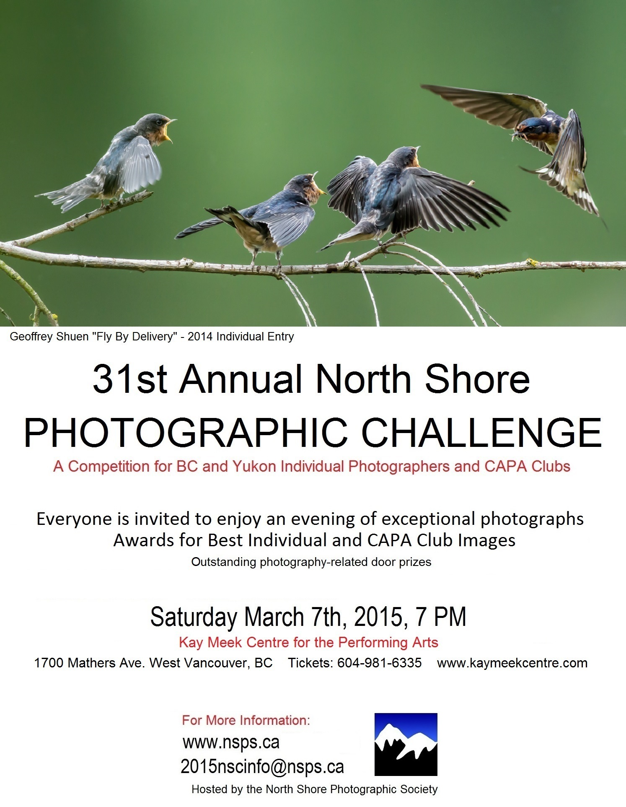

31st North Shore Photographic Challenge

Saturday March 7, 2015

Open to Individual Submissions
After the success of our new format introduced last year, The North Shore Photographic Challenge is pleased to continue including entries from individual photographers, whose best work will be shown together with select entries from CAPA-member photo clubs across BC and the Yukon in a spectacular evening of top-quality competitive photography.
Advance tickets to the show are $20 ($22 at the door). Visit the Kay Meek Centre website at http://www.kaymeekcentre.com, order by phone at 604-981-6335, or email the North Shore Photographic Society’s Challenge committee at 2015nscinfo@nsps.ca.
Everyone who enjoys creative photography, visual ideas and techniques, both classic and cutting-edge, will take away something from this event—including, if you’re lucky, one of many great door prizes from our generous corporate sponsors

The Challenge Format
Entries from individuals and clubs will be randomly mixed in competition. The judging panel will score each image out of a maximum of 27 points, as in previous years.
Two sets of CAPA medals will be awarded for single images: 1st, 2nd, and 3rd prize for images submitted by clubs, and 1st, 2nd, and 3rd prize for images submitted by individuals. The top-scoring image will receive the NSPS Best in Show medal. If there is a point tie between the top individual and club images, the judges will rule which one is Best In Show.
CAPA-member photo clubs will vie for the coveted North Shore Photographic Challenge trophy. Each club will submit 6 images.
As always, the Challenge is open-theme, admitting images of all subjects. Digital manipulation of photos is allowed. However, since the Challenge is a family event, images with ‘adult’ content may be disqualified.

Rules for Individual Submissions
For a $12 entry fee (or $22 bundle price for entry plus a ticket to the event), each individual photographer may submit up to 3 images for first-round screening by a panel of qualified judges. From the 3 images, the panel will select at most 1 to compete in the Challenge. There is no guarantee that any of an individual’s images will be included in the final March 7, 2015 competition.
A photographer whose work is included in a club entry may also enter as an individual.
Images must be the original work of the entrant.
Entrants retain copyright to their submitted images. However, entering the competition indicates that the image-maker has given permission to have his or her images duplicated, and used to advertise and promote future Challenge events.
Images may not have been entered in a previous North Shore Challenge competition.
Individual entrants are not required to be CAPA members.

How to Enter the Individual Competition
- The deadline for individual submissions is February 7, 2015.
- Prepare your images (up to 3) to the following specifications:
- maximum width 1400 pixels
- maximum height 1050 pixels
- JPG file format
- Prepare a title for each image. The title will be announced before the image is judged.
- Get ready to pay the $12 entry fee, or $22 entry-plus-ticket price, through PayPal. (Major credit cards accepted.) This is non-refundable.
- Click here to proceed.

